Tasks for App and Web servers.

- Install nginx and run nginx on port number 81.
• Install Nginx
• Open Nginx configuration file
• Change default port from 80 to 81
• Save and exit
• Start Nginx service
• Enable Nginx service
• Open port 81 in Security Group
• Verify using browser with http://<public-ip>:81
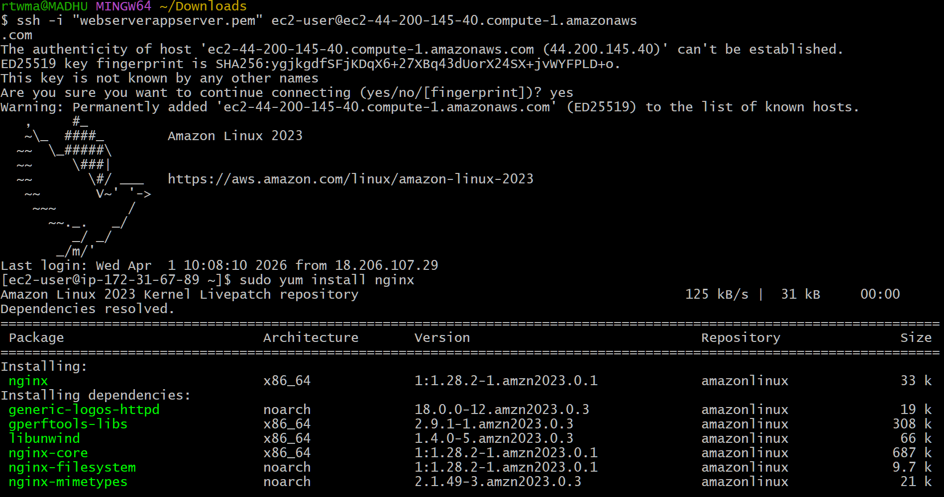
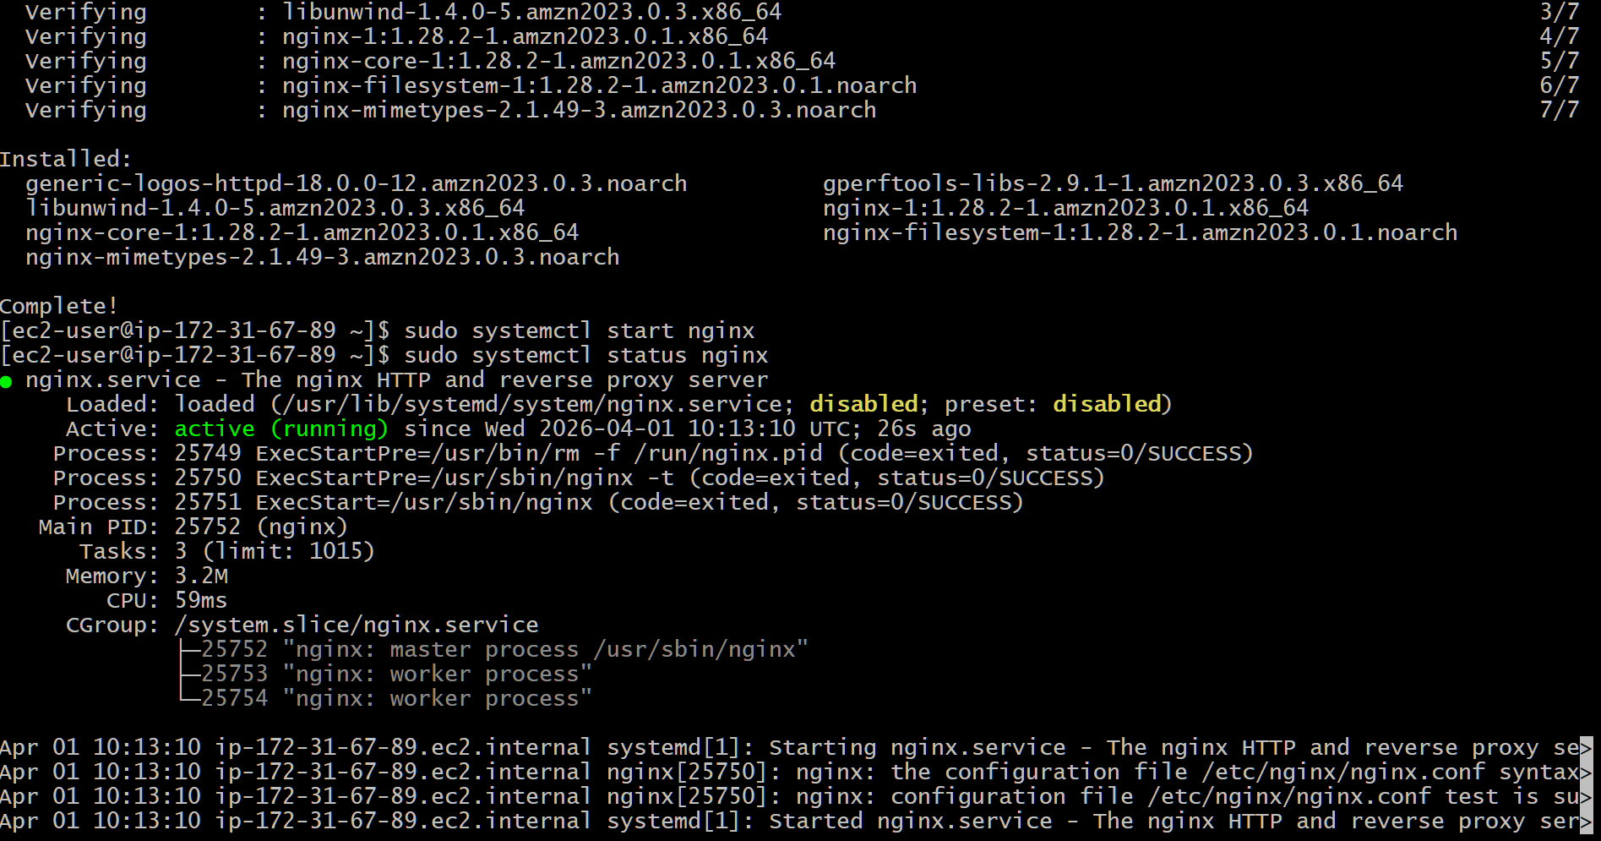
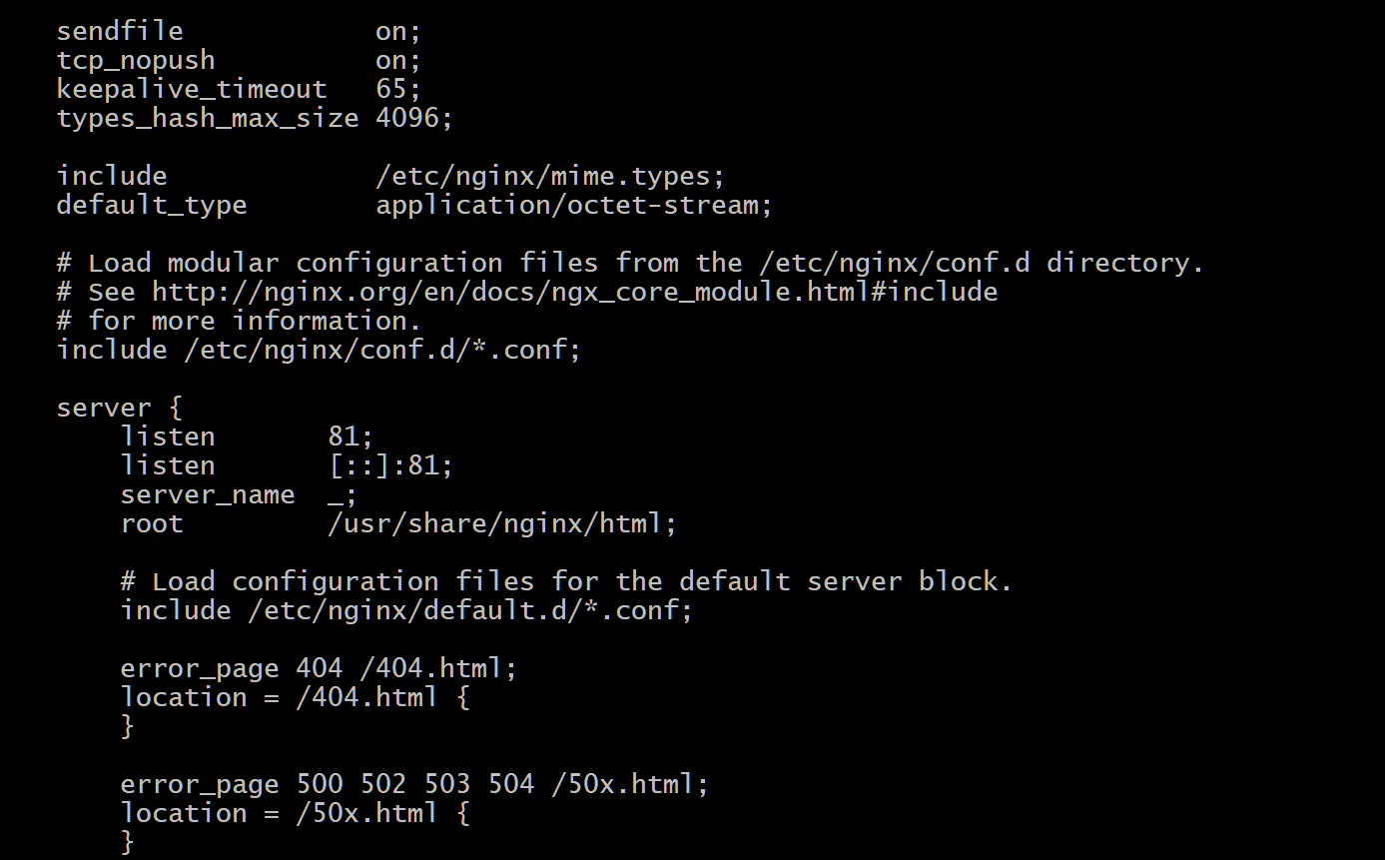

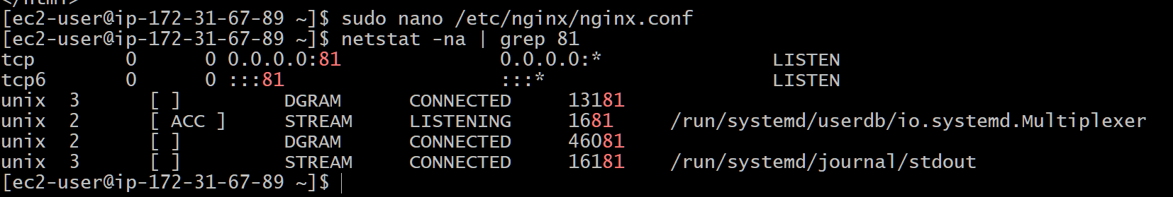



- Deploy a sample index.html file on nginx.
• Navigate to Nginx web directory (/usr/share/nginx/html)
• Create or edit index.html
• Add sample HTML content
• Save file
• Restart Nginx
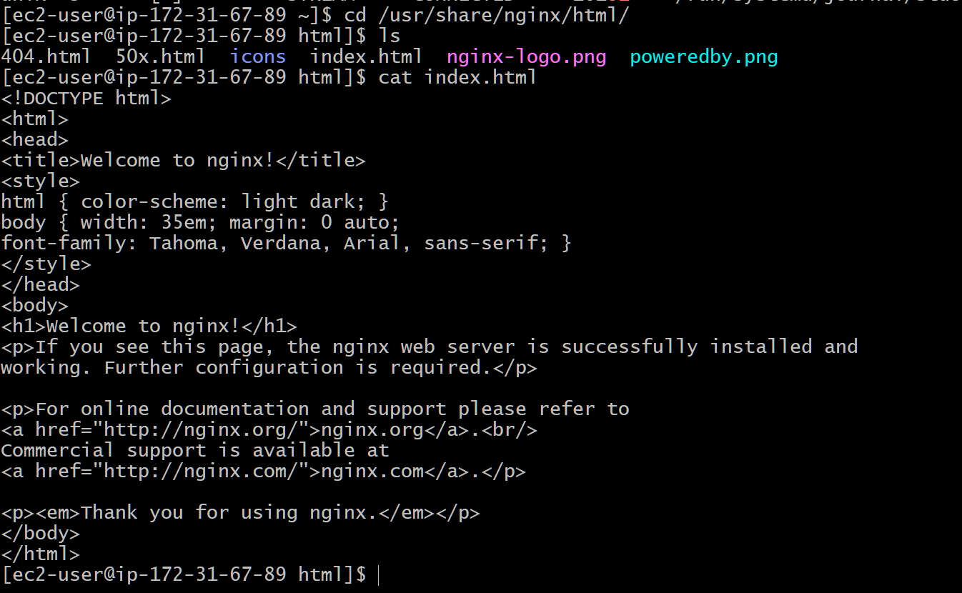

- Install Apache and run Apache on port number 82.
- Install Apache (httpd)
- Open Apache config file (/etc/httpd/conf/httpd.conf)
- Change port from 80 to 82
- Save and exit
- Start Apache service
- Enable Apache service
- Open port 82 in Security Group
- Verify using browser with http://<public-ip>:82

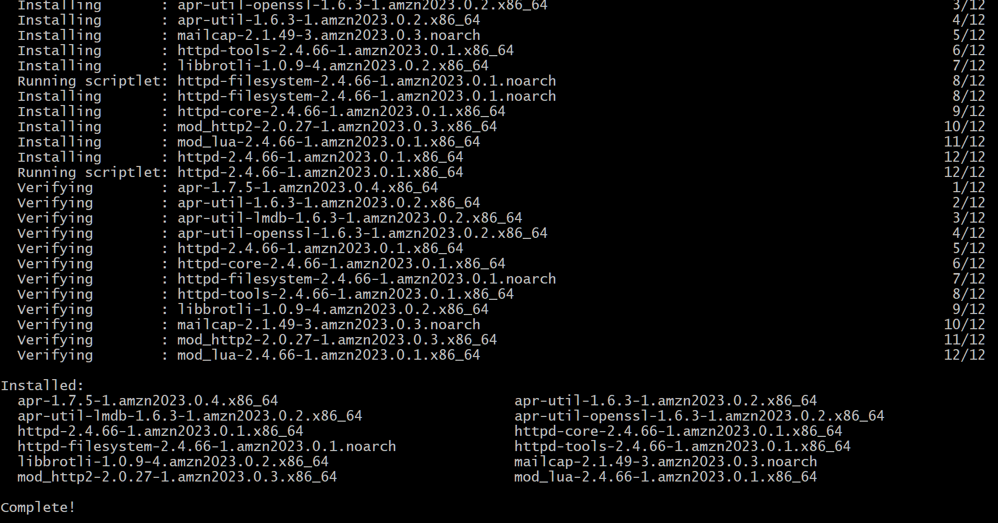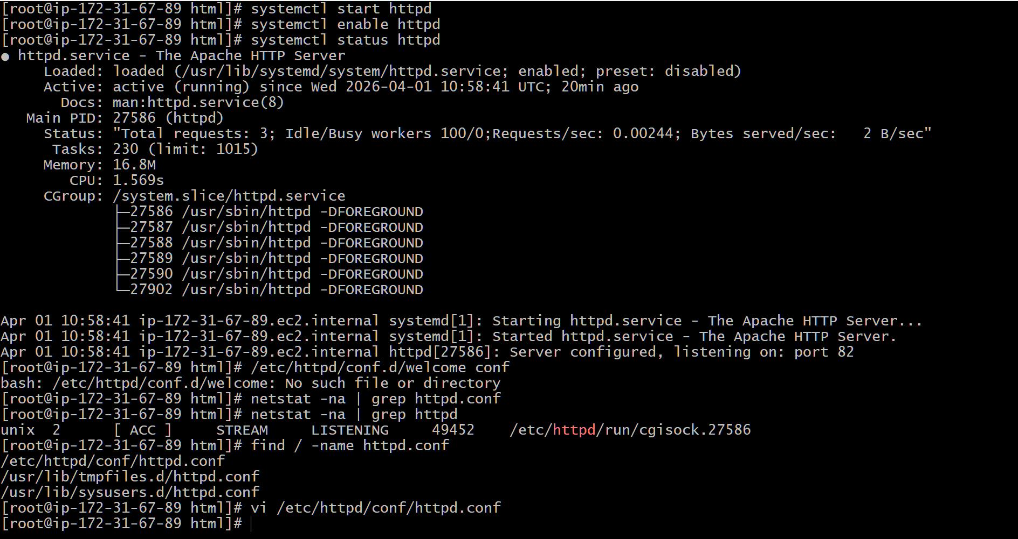
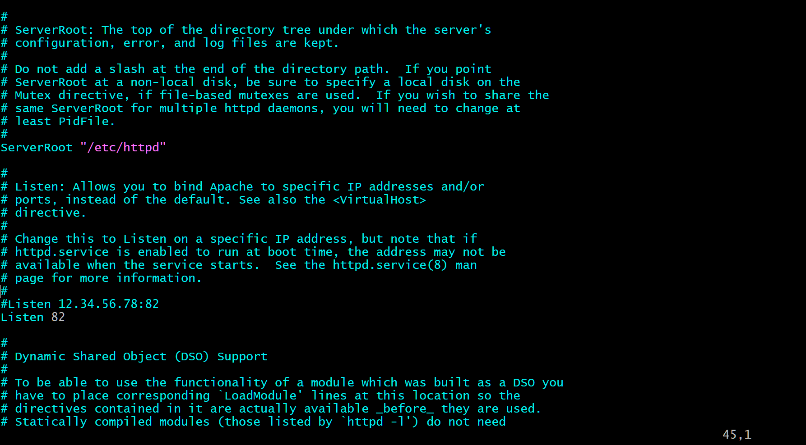
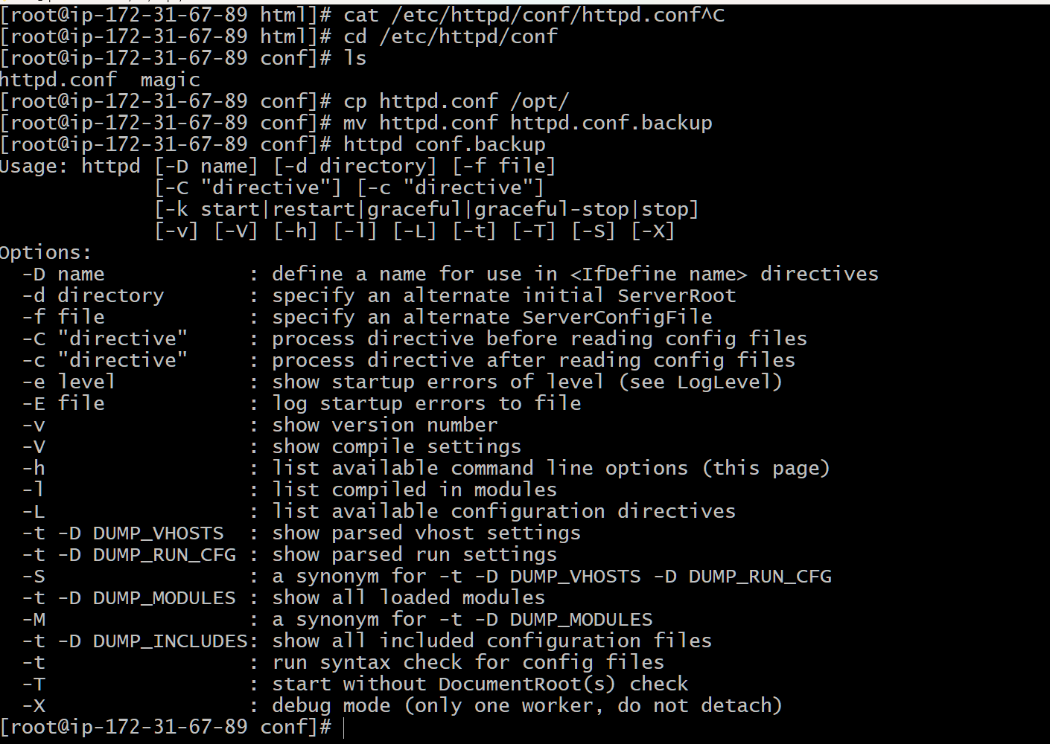
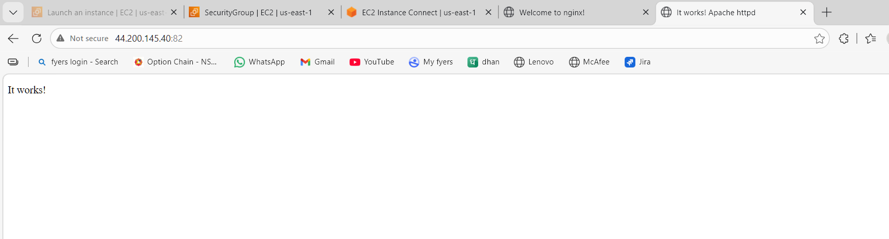

- Deploy a sample index.html file on Apache.
• Navigate to Apache web directory (/var/www/html)
• Create or edit index.html
• Add sample HTML content
• Save file
• Restart Apache
• Verify in browser
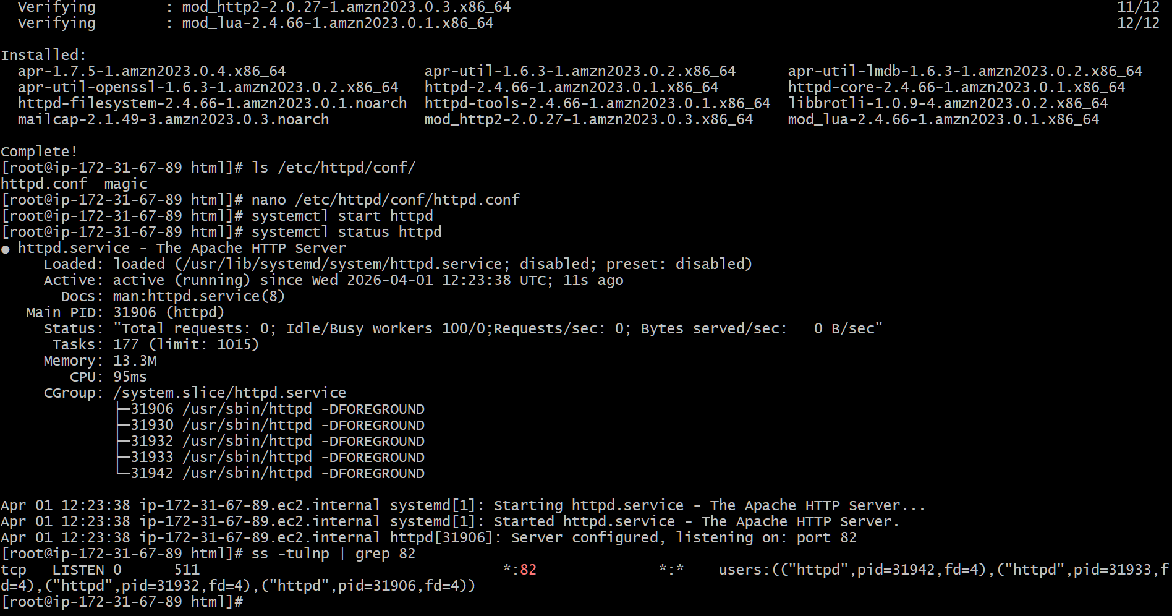
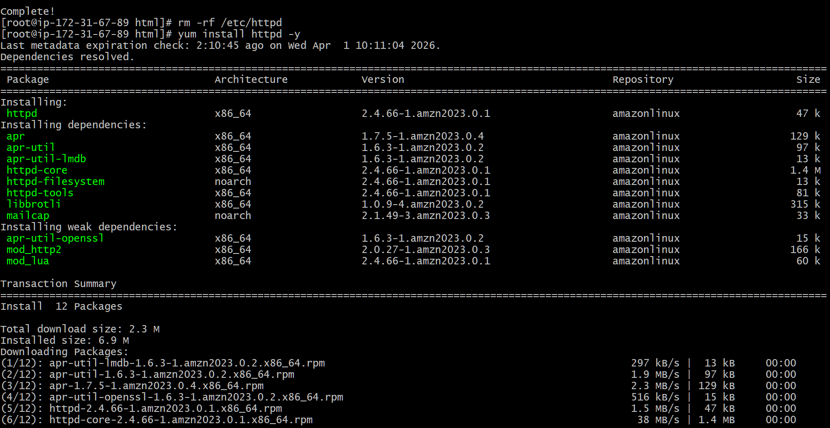


5) Install Apache tomcat on port number 8082
- Install Java (required for Tomcat)
- Download Tomcat package
- Extract Tomcat in /opt directory
- Rename folder to tomcat
- Open server.xml file
- Change port from 8080 to 8082
- Change shutdown port if conflict occurs
- Start Tomcat using startup script
- Open port 8082 in Security Group
- Verify using browser with http://<public-ip>:8082
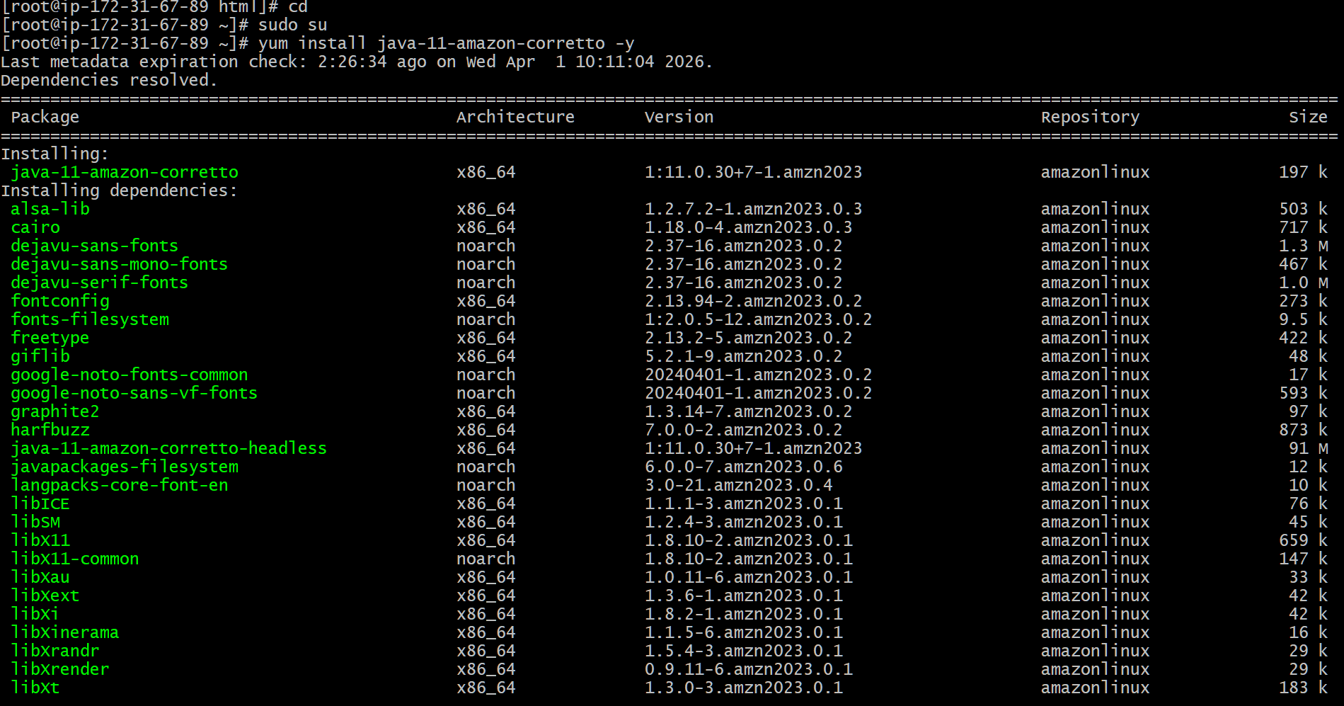
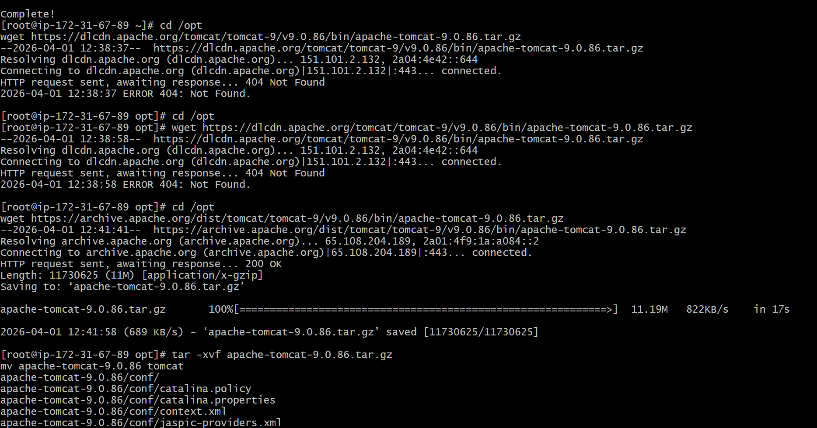

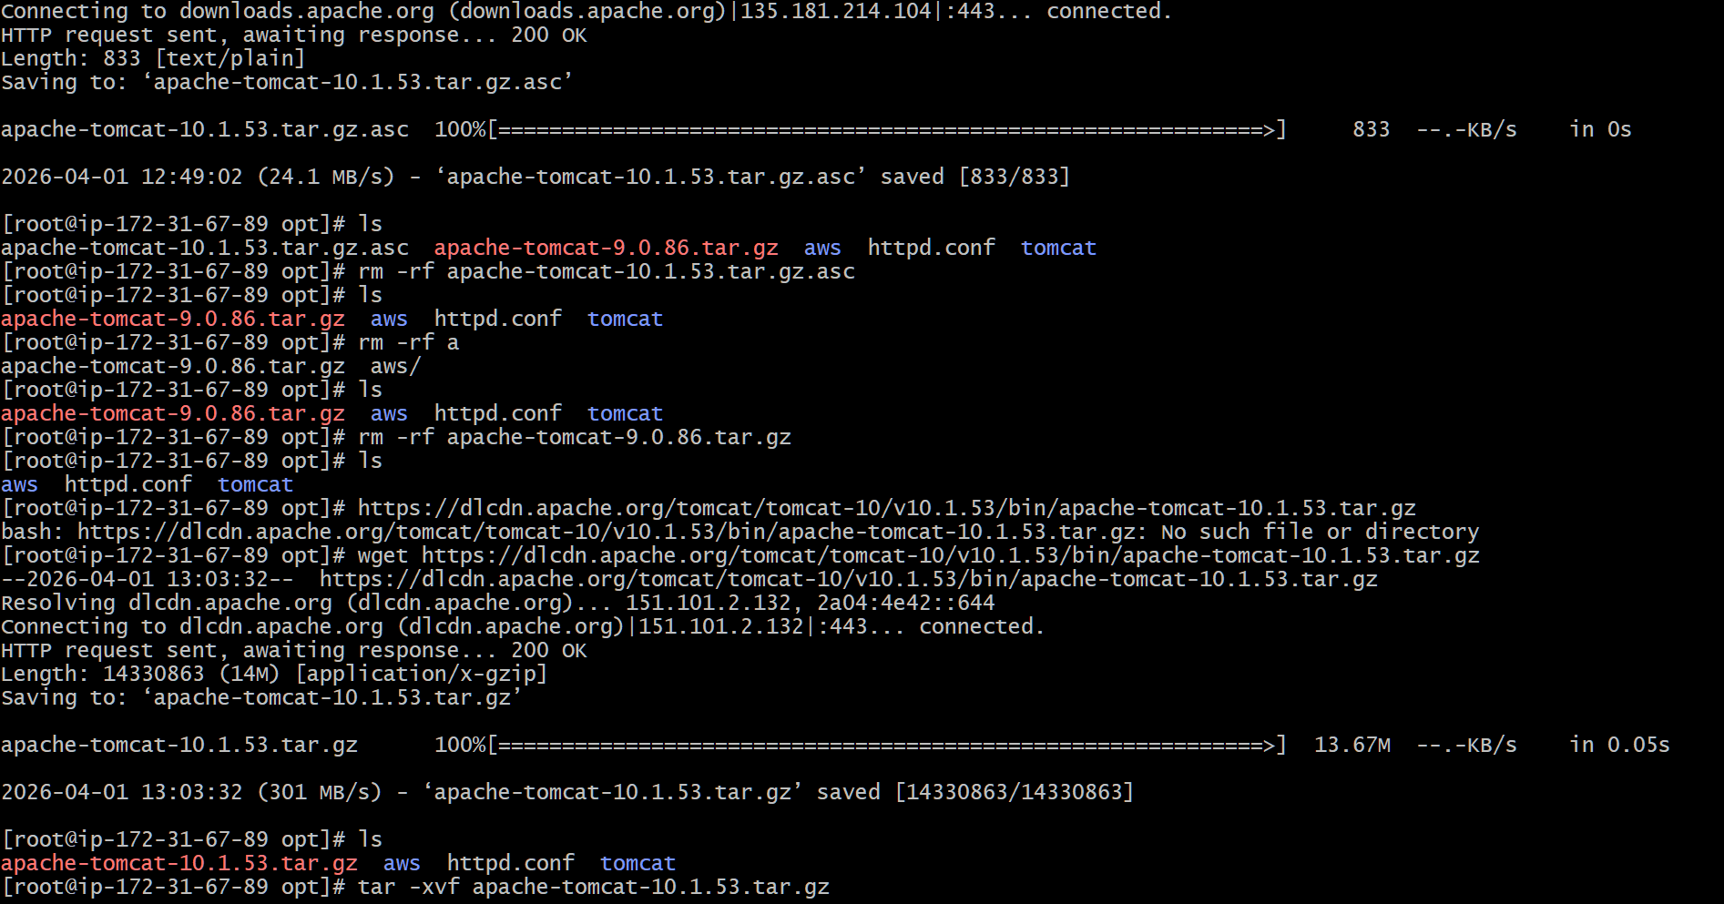
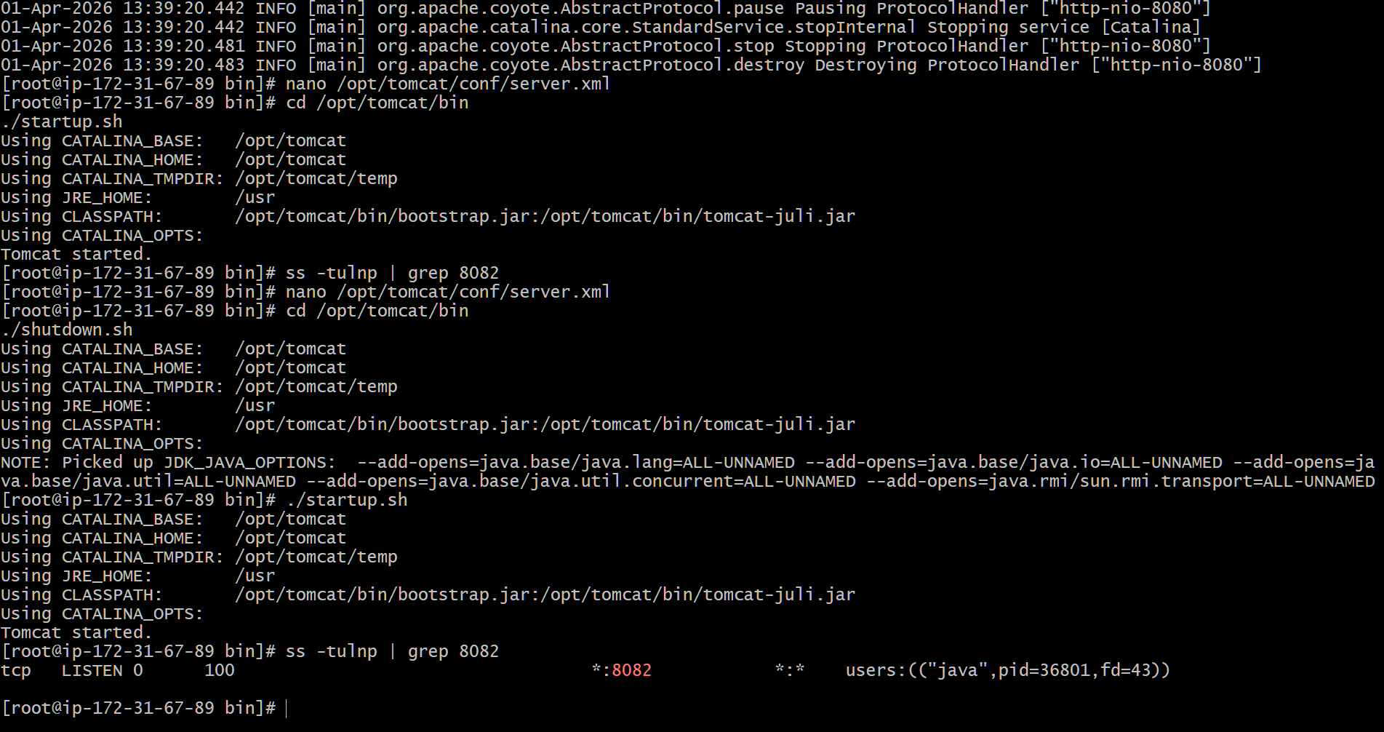
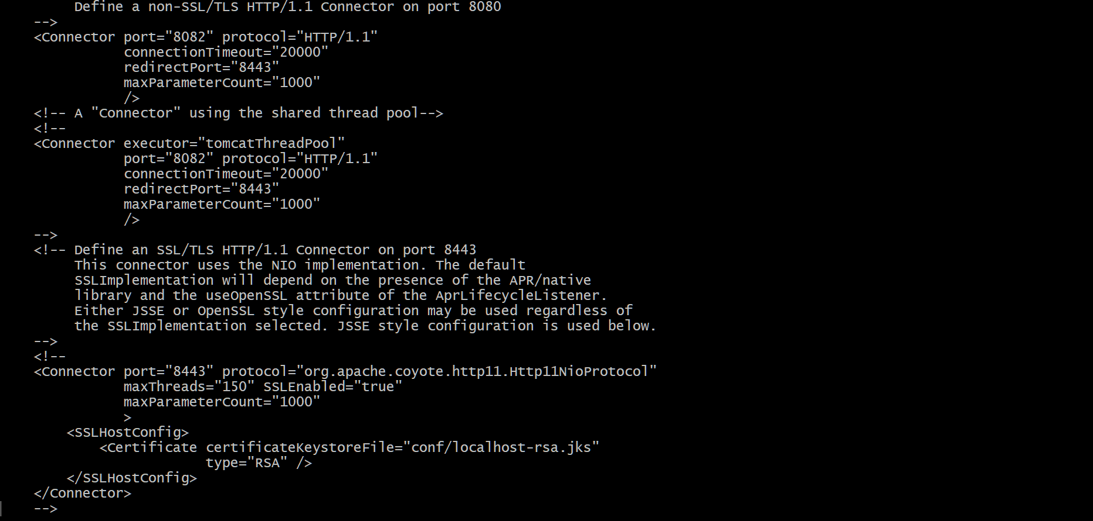
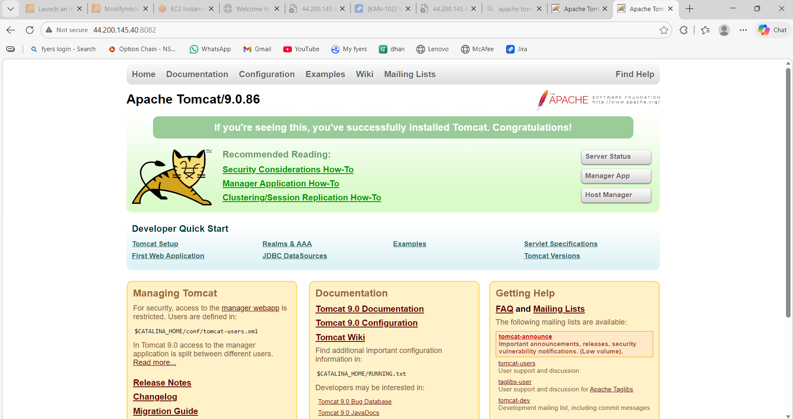

6) Deploy a sample app on webapps
- Navigate to /opt/tomcat/webapps
- Create a new folder (e.g., myapp)
- Inside folder, create index.jsp
- Add sample JSP content
- Save file
- Restart Tomcat
- Verify using browser with http://<public-ip>:8082/myapp
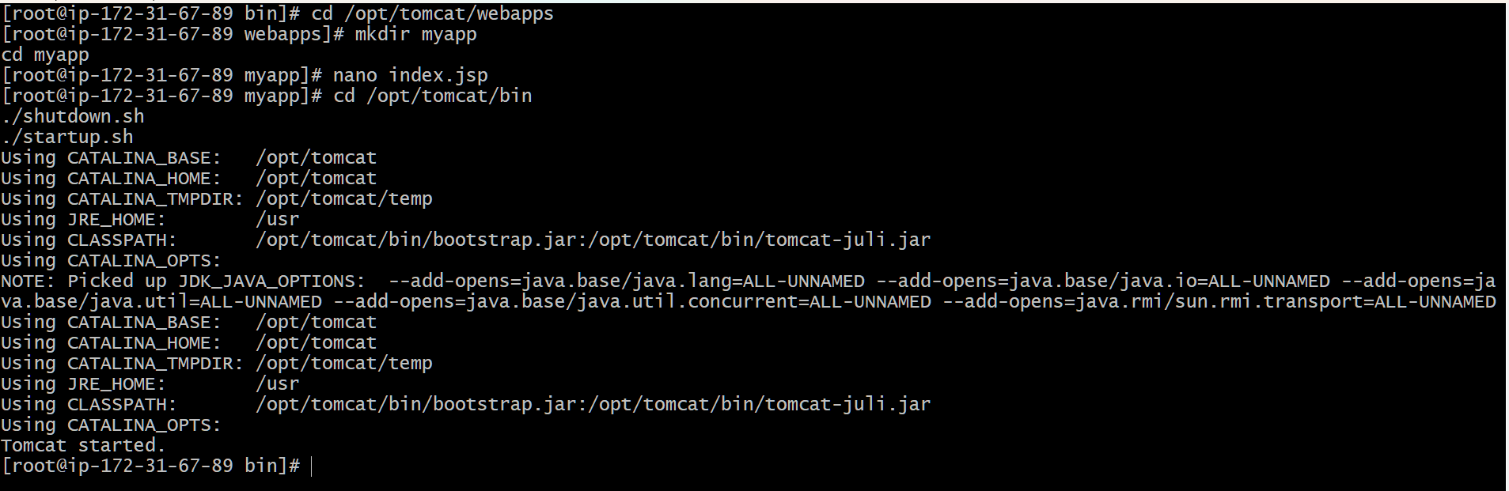
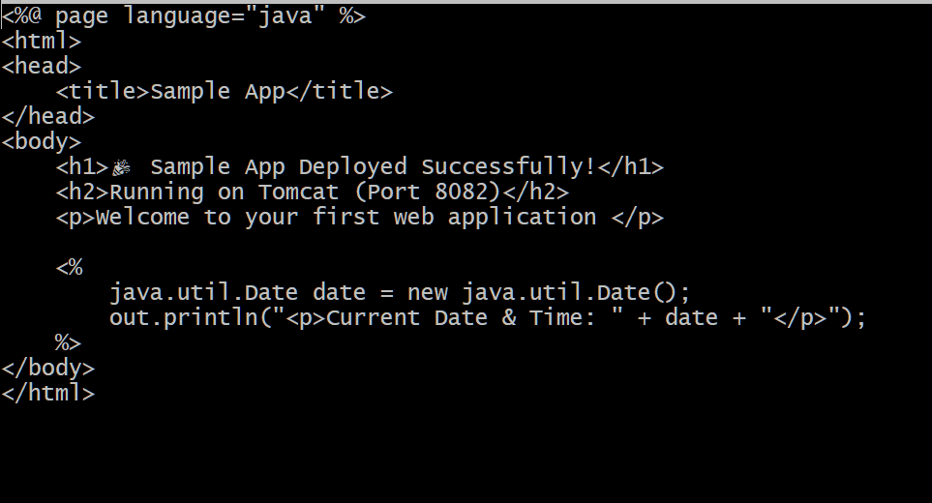
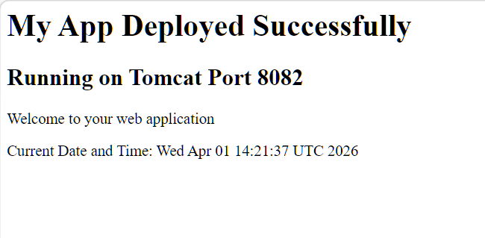

7) Create a tomcat.service file for tomcat.
- Navigate to /etc/systemd/system
- Create file tomcat.service
- Add service configuration (Java path, Tomcat path, start/stop scripts)
- Save file
- Reload systemd daemon
- Start Tomcat service
- Enable service for auto-start
- Check service status

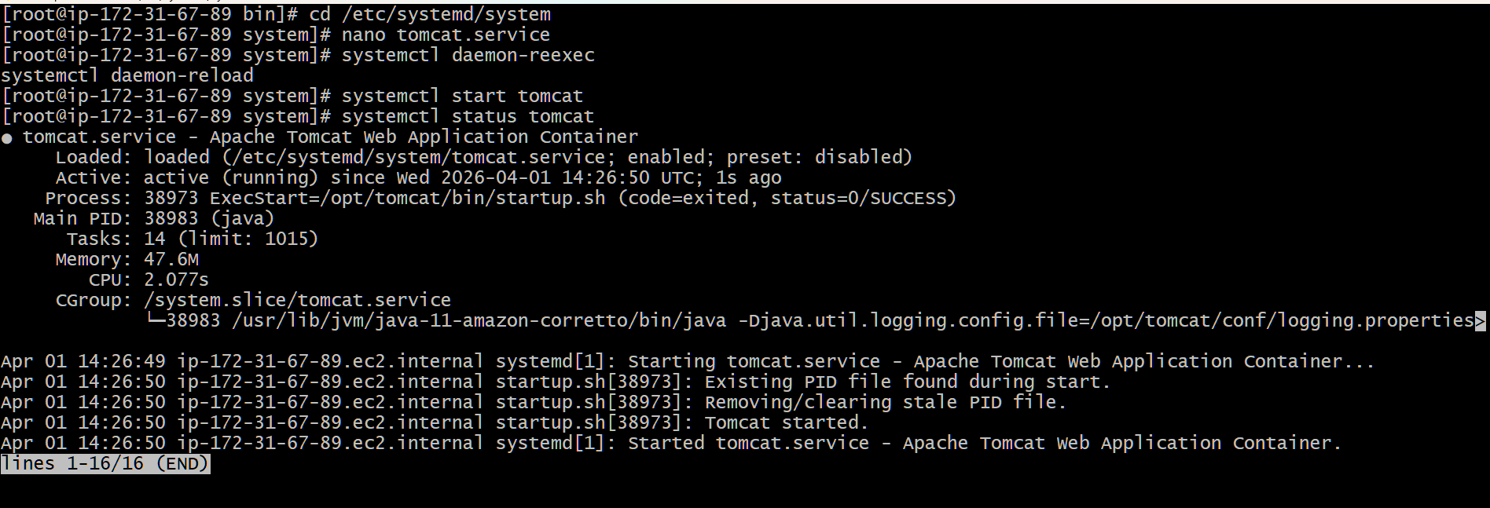
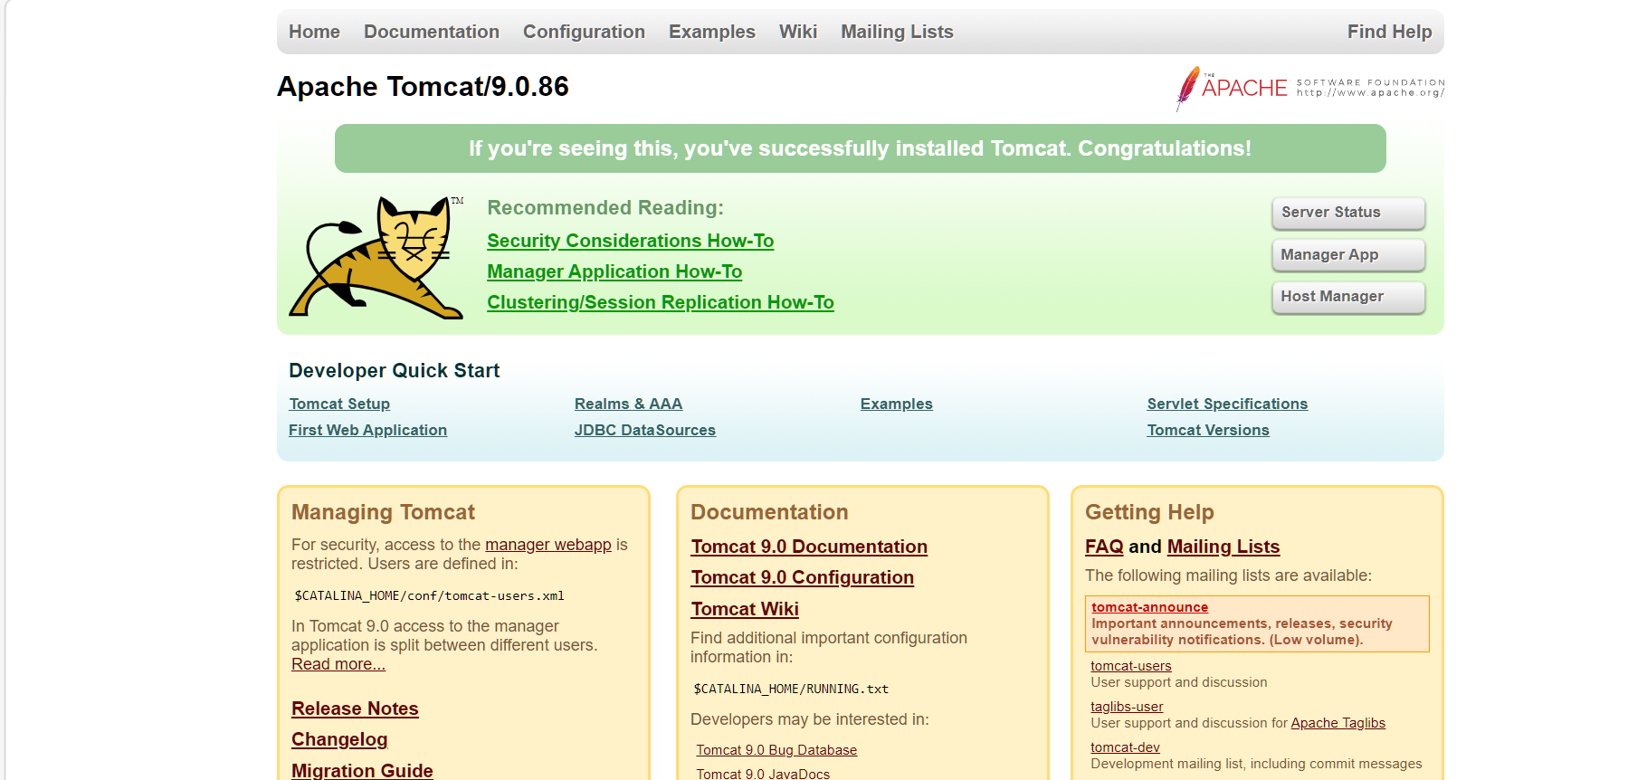

8) Configure HA Proxy serve
- Install HAProxy
- Open HAProxy configuration file (/etc/haproxy/haproxy.cfg)
- Configure frontend to listen on port 80
- Configure backend servers:
- Nginx → port 81
- Apache → port 82
- Tomcat → port 8082
- Save configuration
- Start HAProxy service
- Enable HAProxy service
- Open port 80 in Security Group
- Verify using browser with http://<public-ip>

